Q) what is the best way to integrate with kubernetes and Jenkins?

Ans:-
Using the .kube/config file in Jenkins works, especially for learning and small labs, but it is not the best practice for production.
Here's how I would rank the approaches:
Method | Security | Ease | Recommended
Kubeconfig file as Jenkins Secret File | ⭐⭐⭐ | ⭐⭐⭐⭐⭐ | ✅ Good for learning and small teams
Jenkins Kubernetes CLI Plugin + Secret File | ⭐⭐⭐⭐ | ⭐⭐⭐⭐ | ✅ Recommended
Service Account + RBAC Token | ⭐⭐⭐⭐⭐ | ⭐⭐⭐ | ✅ Best for production
Jenkins running inside Kubernetes (Kubernetes Plugin) | ⭐⭐⭐⭐⭐ | ⭐⭐ | ✅ Enterprise environments
GitOps (Argo CD / Flux) with Jenkins | ⭐⭐⭐⭐⭐ | ⭐⭐ | ⭐⭐⭐⭐⭐ Best modern approach

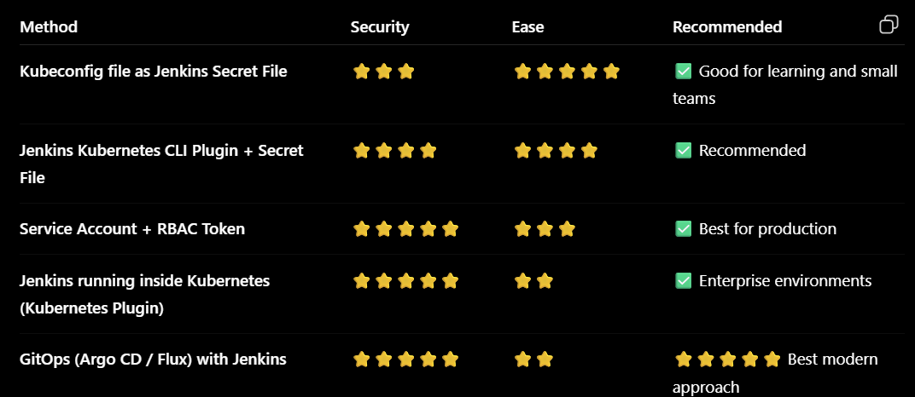

Option 1: Kubeconfig File (What you're learning)
This is exactly what you're doing.
Jenkins
│
├── Secret File (.kube/config)
│
└── kubectl apply
│
▼
Kubernetes Cluster
Jenkinsfile:
withCredentials([file(credentialsId: 'kubernetes', variable: 'KUBECONFIG')]) {
sh '''
export KUBECONFIG=$KUBECONFIG
kubectl apply -f deployment.yml
'''
}

Advantages
- Very easy
- Good for VirtualBox
- Good for kubeadm
- Easy to understand

Disadvantages
- Full kubeconfig contains cluster credentials.
- Harder to rotate credentials.
- If leaked, it may provide broad cluster access.
For your current learning environment, this is perfectly fine.

Option 2: Service Account + RBAC (Recommended)
Instead of copying your admin kubeconfig, create a dedicated ServiceAccount with limited permissions.
Example:
apiVersion: v1
kind: ServiceAccount
metadata:
name: jenkins
Create a Role:
kind: Role
Bind it:
kind: RoleBinding
Generate the token:
kubectl create token jenkins
Configure Jenkins to use that token.

Advantages
- Least privilege
- Much more secure
- Easy to revoke
- Production-ready
This is the approach most companies use if Jenkins deploys directly to Kubernetes.

Option 3: Jenkins in Kubernetes
Kubernetes
├── Jenkins Pod
├── Build Pod
└── kubectl
The Jenkins pod automatically authenticates using its ServiceAccount.
No kubeconfig file is required.
This is very common in enterprises.

Option 4: GitOps (Best Modern Practice)
Today, many organizations avoid letting Jenkins deploy directly.
Instead:
Developer
│
▼
GitHub
│
▼
Jenkins
│
▼
Update Kubernetes YAML
│
▼
Git Repository
│
▼
ArgoCD
│
▼
Kubernetes
Jenkins only:
- Builds the Docker image
- Pushes it to Docker Hub or a container registry
- Updates the image tag in the Kubernetes manifests stored in Git
Then Argo CD (or Flux) watches the Git repository and deploys the changes automatically.

Benefits
- Git is the source of truth.
- Easy rollback.
- Full audit history.
- No direct cluster credentials in Jenkins.
- Preferred by many modern DevOps teams.

What I recommend for your learning path
Since you're building a kubeadm cluster in VirtualBox and practicing Jenkins CI/CD, I suggest progressing in stages:
- Current stage (keep using it)
  - Jenkins
  - Docker
  - .kube/config
  - kubectl apply
- Next stage
  - Create a Kubernetes ServiceAccount
  - Add RBAC
  - Use a restricted token instead of the admin kubeconfig
- After that
  - Learn Helm
  - Deploy with helm upgrade --install
- Advanced stage
  - Jenkins builds and pushes the image
  - Argo CD handles deployment (GitOps)

Recommendation for your current learning
Based on what we've worked on together (VirtualBox, kubeadm, MetalLB, Jenkins, Docker, and Kubernetes), I'd recommend the following roadmap:
- ✅ Jenkins → Git checkout
- ✅ Build Docker image
- ✅ Push image to Docker Hub
- ✅ Deploy with kubectl using a kubeconfig secret (your current setup)
- ✅ Add image versioning instead of always using latest
- ✅ Learn Helm deployments
- ✅ Finally, move to Argo CD for GitOps-based deployments
This sequence mirrors how many teams evolve from a basic CI/CD pipeline to a production-grade deployment workflow while keeping each step understandable.

